First of all, we are concerned about the cheak-in interface of the website. The focus is on the input method. Today, with the increasingly powerful search engines, there are many input bars on the Internet that can be used for reference for our website. Such as Google ([www.google.com](http://www.google.com)) and Yahoo([www.yahoo.com](http://www.yahoo.com)) : 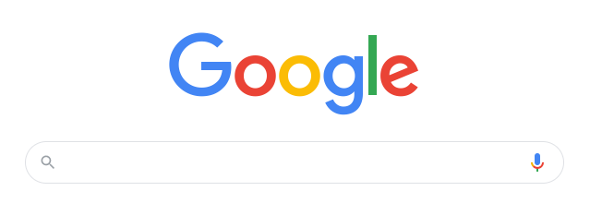

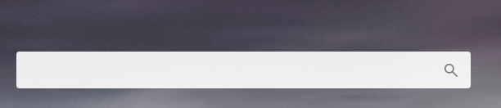They use a similar layout. This classical design is easy to highlight the core functions of the website, which is very concise and convenient.

Furthermore, what we consider is how to display the contact’s itinerary and corresponding data on the page. At this time, the introduction of Google Calendar API is the best choice, but we have made a different choice in the way of display. At present, most of the websites we see have maps and data placed in the form of Google calendar (https://calendar.google.com/calendar): 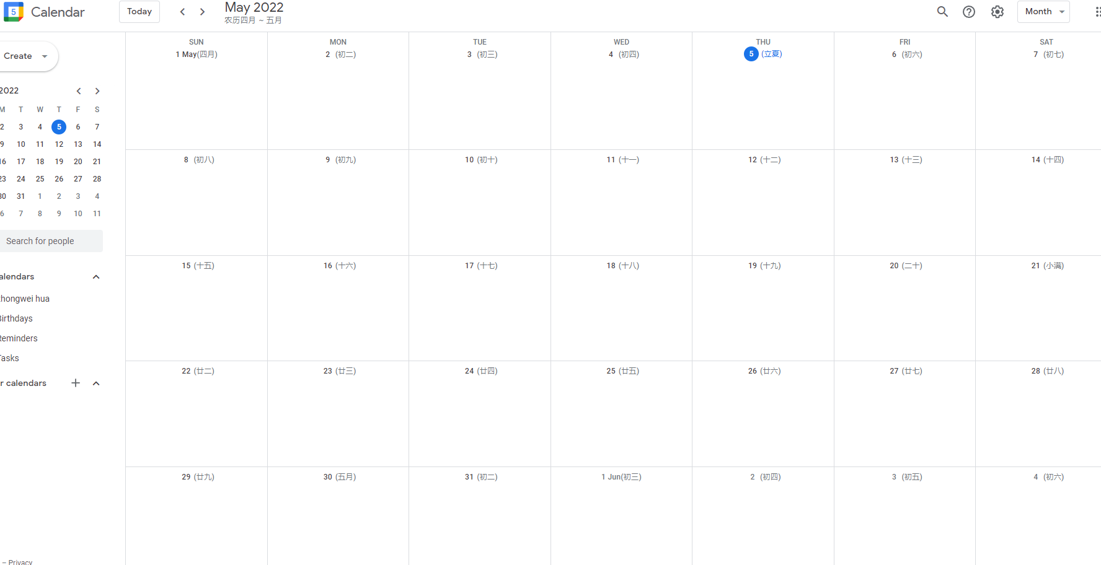

But we believe that the data is placed on the left. Considering that most people are right-handed, this layout will bring a bad experience to many users when filtering and analyzing the data, so we put the data column on the left, and believe that this approach will bring a more comfortable experience for users.

After the main functional components were considered, we proceeded to design the page header of the web page and the way to switch between the sub-sections. We first browsed NYTimes (<https://www.nytimes.com/>), the layout of its header looks like this: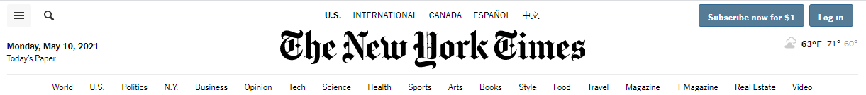

We centered the headline to make the sub-columns look inconspicuous, and the page looks quite crowded, so we refer to the design of TED (<https://www.ted.com/>):

This seems a lot lighter, but we want to separate the user's login and registration functions from the actual content, which will make the function distribution of the entire website look clearer. Therefore, we finally refer to ABCNews (<https://abcnews.go.com/>) header design:

The content of the web page is placed on the left, and user-related functions are placed on the right. This design has been unanimously approved by our team and finally applied to our own website.

Regarding the user’s login and logout interface, we initially hoped to design it to be larger, which seems to make the style of the entire website more solemn and fresh, and promote the user’s desire to use, such as Reddit (<https://www.reddit.com/>). The design scheme used:

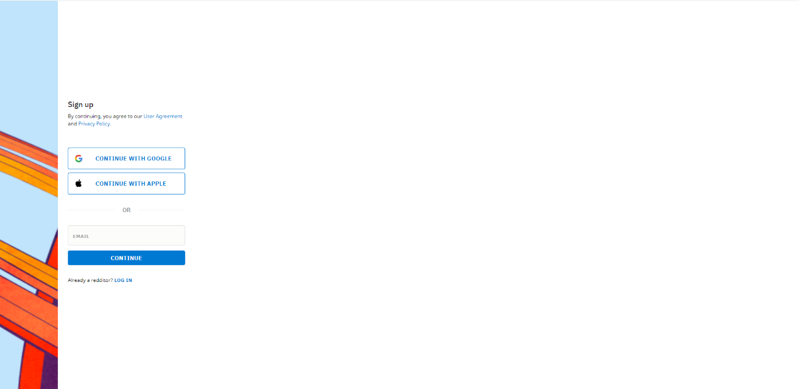

The large-scale white space creates a sharp contrast with the very small areas of color, which creates a great visual conflict effect, which makes people excited.

But after some intense discussion, we realized that such an overly artistic design tendency is contrary to the functional concept of the project we designed. As an application aimed at popularization, our style should emphasize simplicity and convenience. Our aim should be to make every user willing to spend a short period of time to use our application, so we have chosen something similar to Instagram (<https://www.instagram.com/>) login interface:

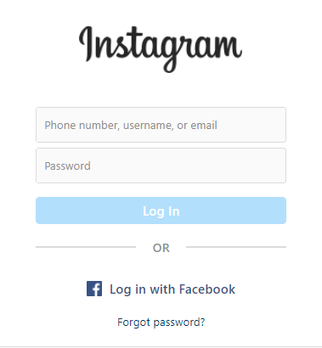

And, in order to facilitate users to log in, we allow users to use other application accounts to log in to our website, so that everyone no longer has to worry about the cumbersome registration process; of course, for those users who are willing to register our website, the registration window will still be reserved for them.

The guide written by Harvard University (<https://iam.harvard.edu/resources/behind-login-screen>) explains how the login authentication in great details. I did learn a lot after reading it and I strongly suggested my group member have a look at it.

One more thing I want to talk about is how might the site look on a phone. We have practiced coding on cs50 ide and check our works on computer for weeks. And I never really thought about the question: How might the website look on cell phone, or a tablet. Will the browser automatically change the size for me? It is common to see some websites provide a WAP page for mobile user and automatically redirect to it when you access, but it sounds way complicated for us. Time to make some research. The encryption part is something we never thought about in our discussion. It might be an overkill for this project, but we are glad to have a try of it.

According to what I got in google (https://www.vicimediainc.com/see-what-a-website-looks-like-on-a-mobile-phone-but-from-your-desktop), we can simply use the developer tools to preview our website on devices of all kinds. All we need to do is click on the smartphone icon in the box that opens up on the right-hand side of the page. Then click on refresh button it will load what the website currently looks like when accessed from a mobile phone.